

Helicopter Ride Registration

Name: ___________________________________________________________

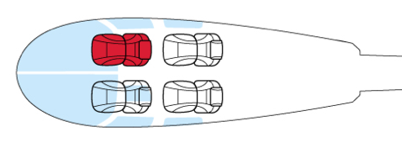
Cell Number: _____________________________________________________

Email: ___________________________________________________________

Emergency Contact Name: ________________________________________ Robinson R44 helicopter

Emergency Contact Phone: ________________________________________
*An Emergency Contact who is NOT flying is recommended but not required.

Total number of seats/passengers requested: 1 ($100) 2 ($200) 3 ($300)

*Flights are in a Robinson R44 Helicopter (3 passenger) + Pilot. The helicopter will be flown with 3 passengers whenever possible (depending on weight), which may mean you will share a ride with other passengers. You may choose to purchase additional empty seats if you desire a private ride.

IN CONSIDERATION of my anticipated flight (s) the legal sufficiency of which is hereby acknowledged, I agree, intending to be legally bound hereby, that Pennsylvania Helicopter Tours LLC (Pilot and/or Operator and/or Owner) (“Released Party”) and Faith Works Aviation, LLC DBA Chester County Aviation (Pilot and/or Operator and/or Owner) (“Released Party”) SHALL NOT BE LIABLE FOR MY DEATH OR INJURY TO MY PERSON, OR FOR ANY LOSS OR DAMAGE TO MY PROPERTY caused in any manner whatsoever, whether attributable to the negligence of the Released Party, or for any other reason, occurring during the time that I am in, entering, or alighting from an aircraft piloted by or under the control of or owned by the Released Party, and I do hereby waive any right of action against the Released Party from any and all causes or claims that I may have against them from the beginning of time. I further agree not to sue on any such cause or claim. This agreement shall not release liability for gross negligence or willful misconduct of the Released Party. I agree to indemnify and hold the Released Party harmless for any losses, judgements or damages he or she may incur, including but not limited to attorney’s fees, arising out any lawsuit related to the flight and/or enforcement of or legal challenge to this agreement. It is my intention that this agreement be interpreted and enforced to the maximum extent allowed by Pennsylvania law.

I have read the Pennsylvania Helicopter Tours LLC and Faith Works Aviation LLC DBA Chester County Aviation Waiver and understand the responsibility for taking this Helicopter Tour.

Printed Name: _________________________ Signature: __________________________ Date: ___________

Printed Name: _________________________ Signature: __________________________ Date: ___________

Printed Name: _________________________ Signature: __________________________ Date: ___________

